* **Create a virtual network with 2 subnets. Each subnet should have 16 Ips only.**

Azure Assignment Submission (Batch-2)

* After Login on Azure Portal, firstly we will click on Virtual Network (Create Virtual Network).
* Under Basic Tab, we will name Resource group. (It can be of any name but here we are writing NewRG01 (RG-Resource Group)), and in the same way we will name our Network( MyVnet01) and choose the region.

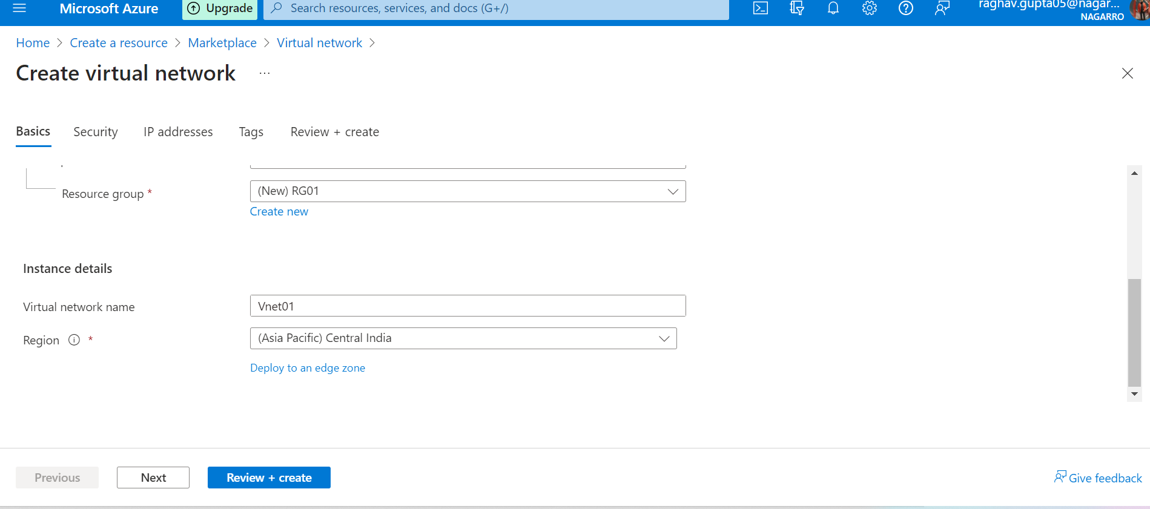

* Under IP Addresses Tab, we will click on Add Subnet to create 2 subnets (as required). We selected the subnet address range such that it should contain 16 Ips only (10.0.1.0/28 and 10.0.2.0/28). 11 Ips + 5 reserved addresses (32-28=4 🡪 24=16).

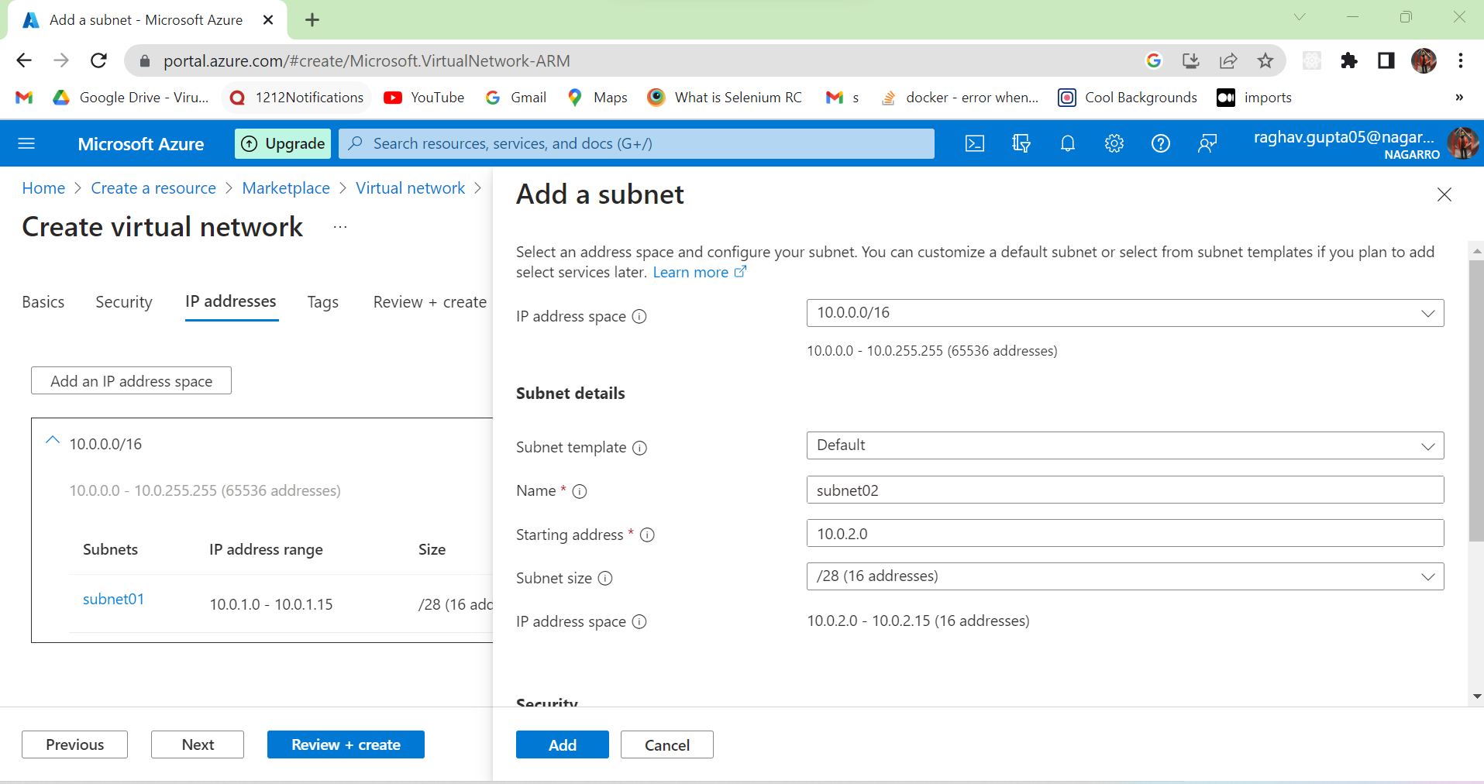

After Passing All the Validations

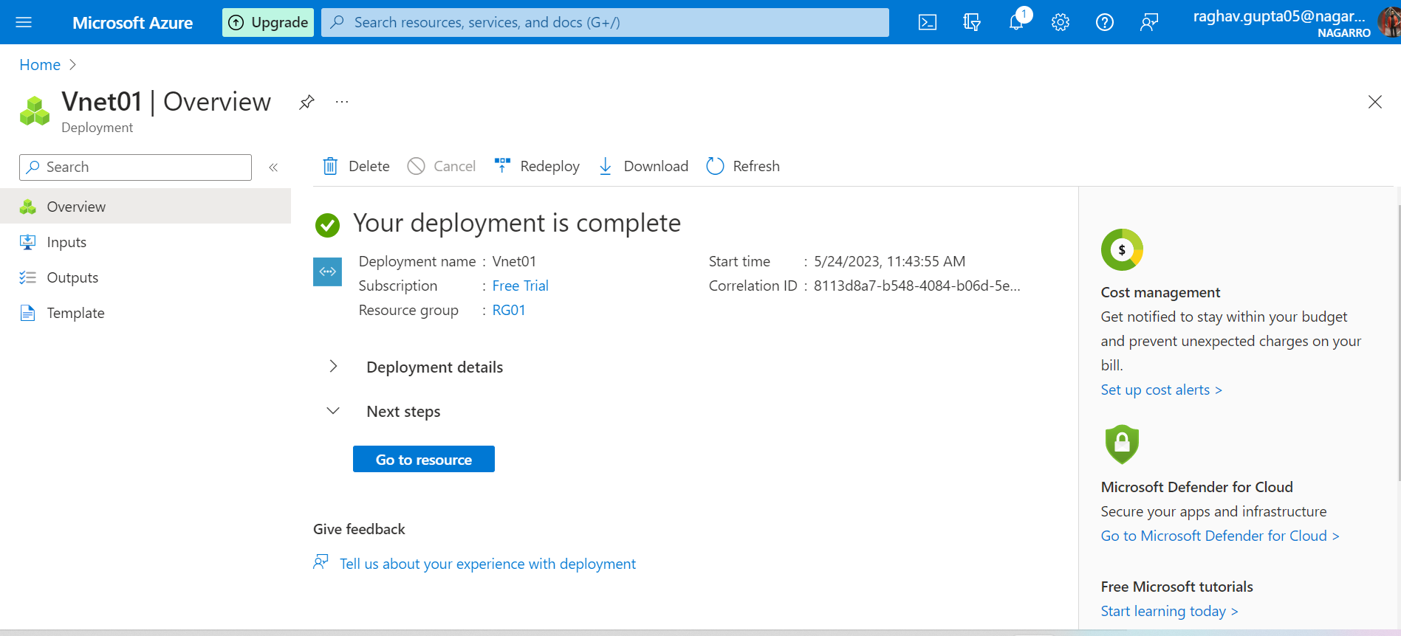

* **Inside one of the subnets, create a VM and deploy an application code inside it and it should leverage the database on the cloud (any existing application created by you before).**
* Firstly, we will click on create resource, Virtual Machine and must select the same resource group which we created before while making virtual network, so that VM remains in one of the above made subnets.

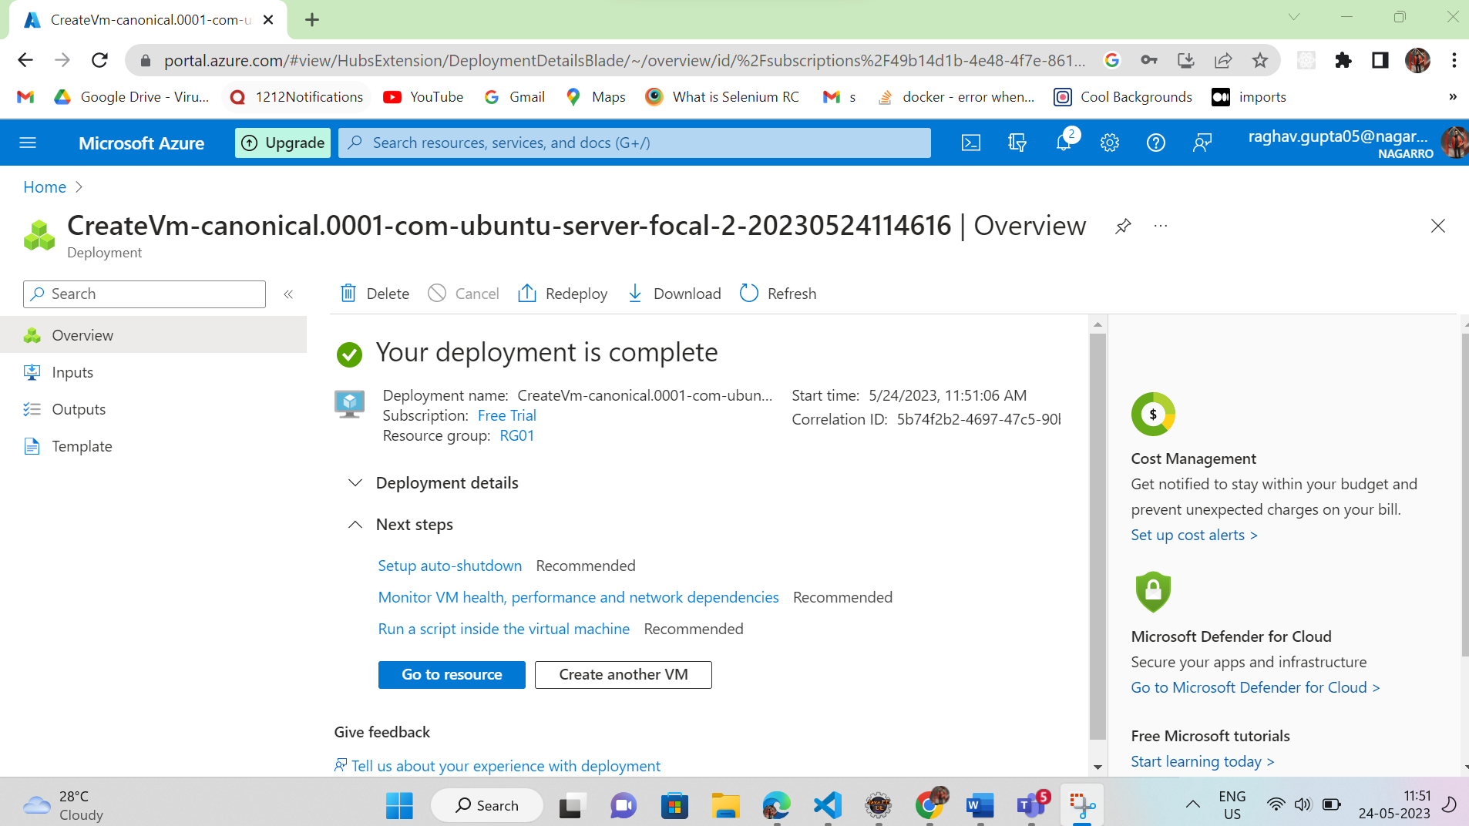

* Now Let’s Deploy our Application on this VM and connect with its Database. Firstly, we will connect our application with SQL Database which we will create on Azure Cloud.
* Now create a SQL Database under Home Tab of Azure and Enter the basics details under Basics Tab as shown in the figure and create SQL server as well.

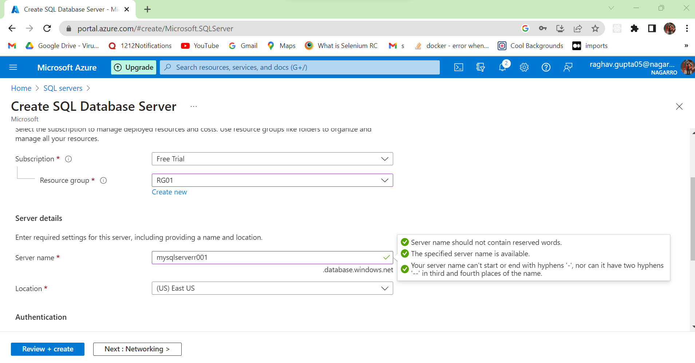

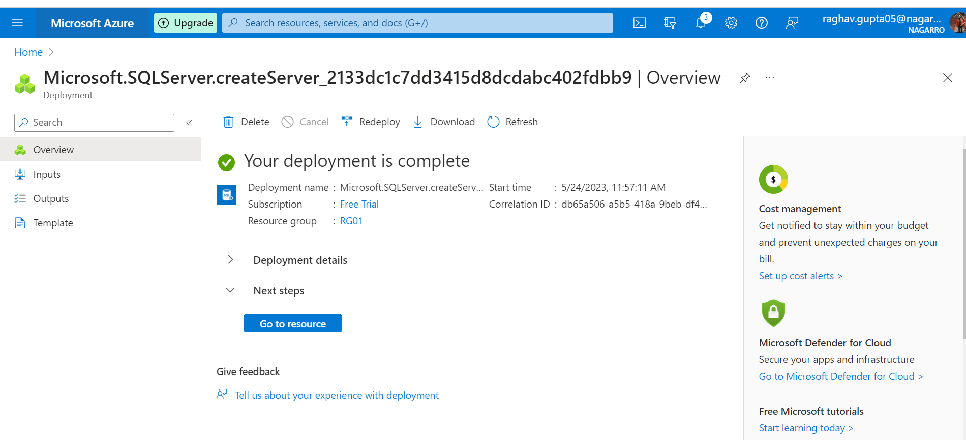

Creating Sql DataBase

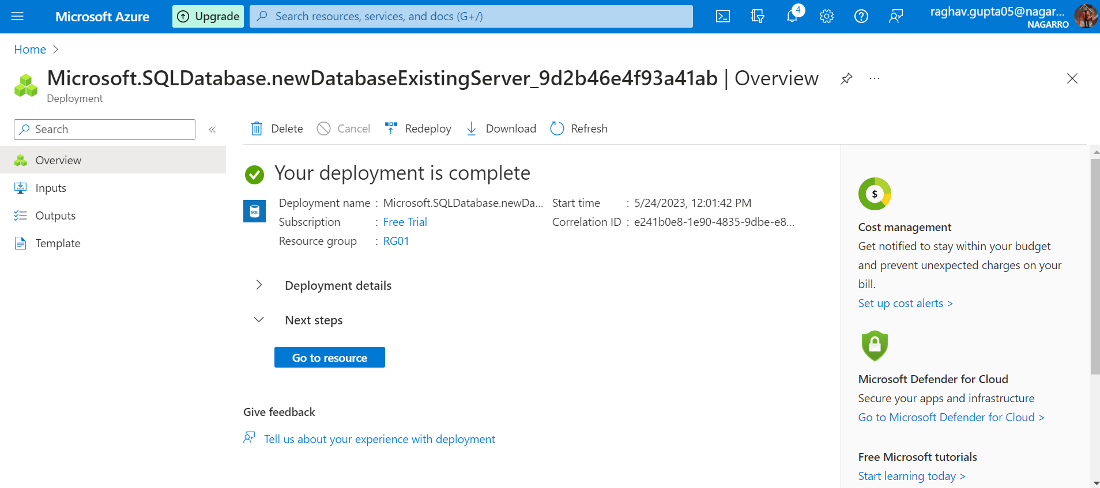

* Now after creating the SQL database, we will click on connection string and add the string, database username and password to our spring application settings to create a connection between our application and Azure SQL database.

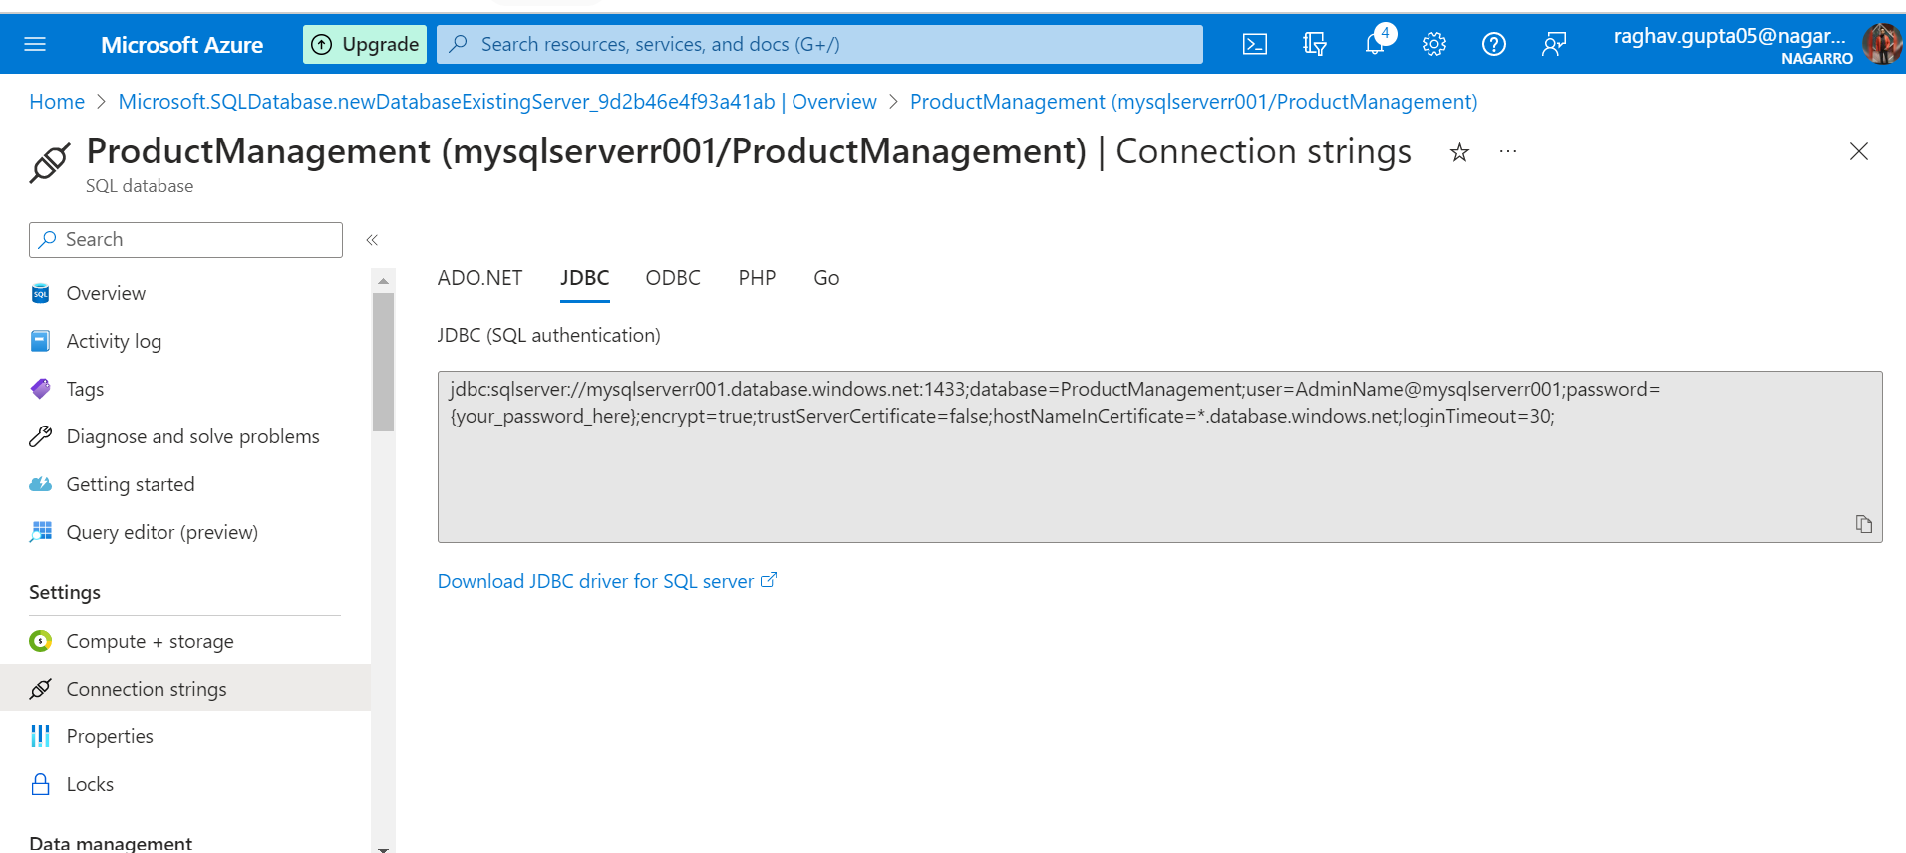

* As we can see in the below screenshot that all the details of the Azure SQL database have been added to our spring application, we will add dependency as well in our spring application as shown in the screenshot in pom.xml file.

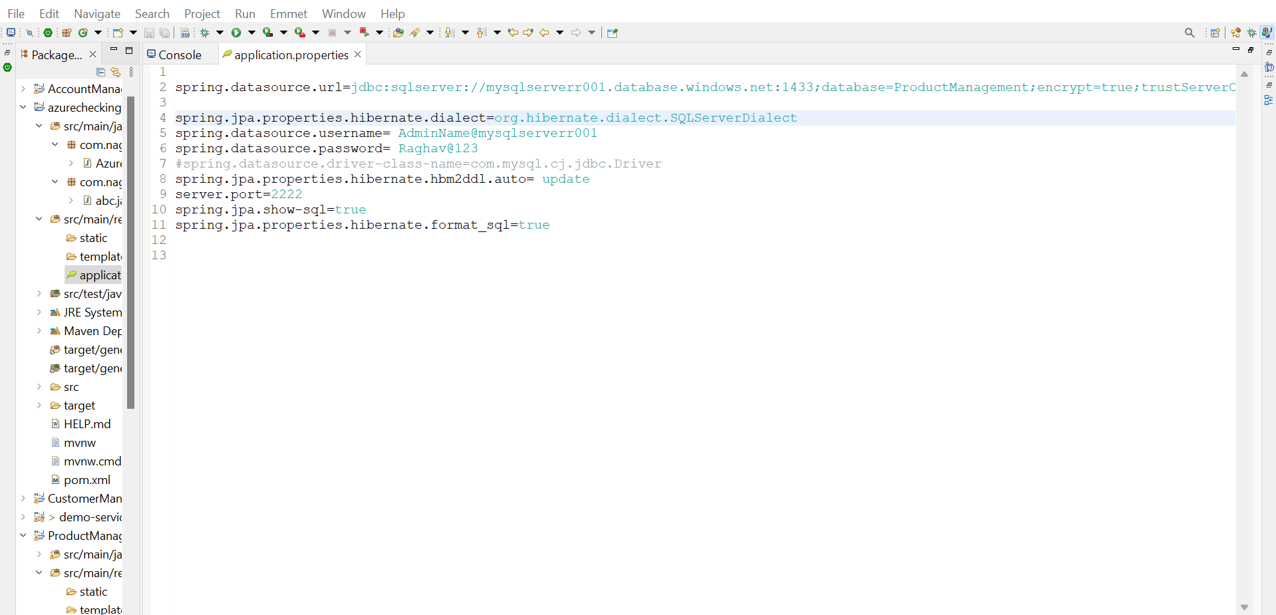

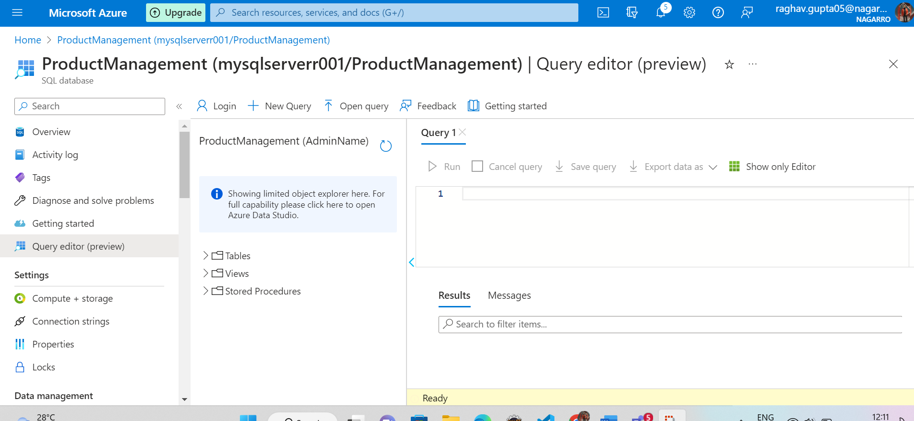

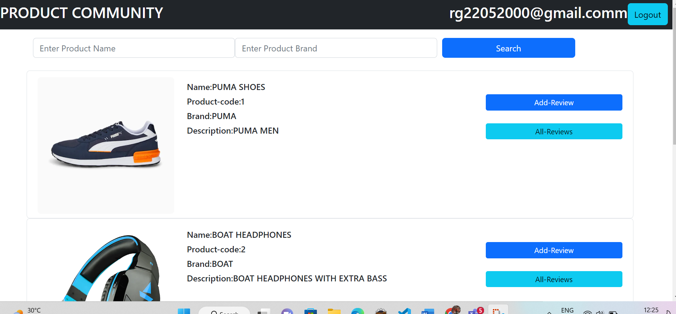

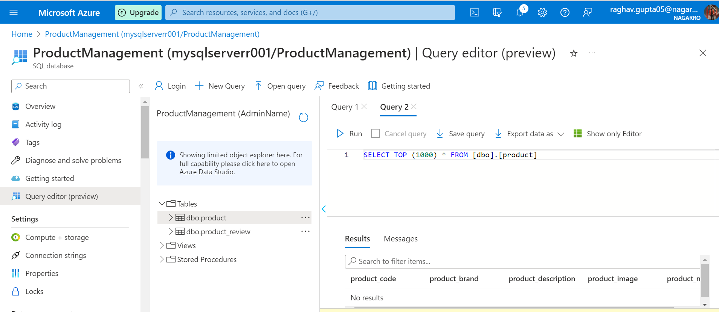

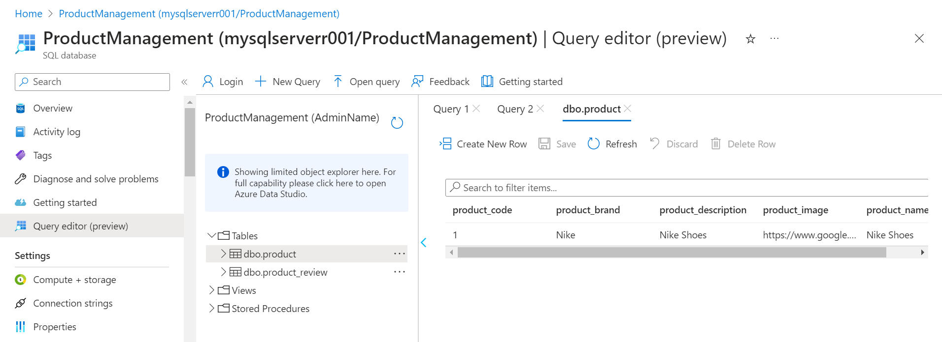

Added One Product Nike Shoes on Sql Server



